Assignment 1 – Part 2



Abdulrahman M Al-Mayouf ID 202002524

Instructor: Dr. Sotirios Zygiaris

BUSI 3331: Business Analytics

2 / 7 / 2024

1. Using Tableau import superstore excel. Create worksheet to the sum of sales per region (column) per product-sub-category(row). Display the cresults as bubble. Place as a title you name and id.

Copy paste the worksheet here

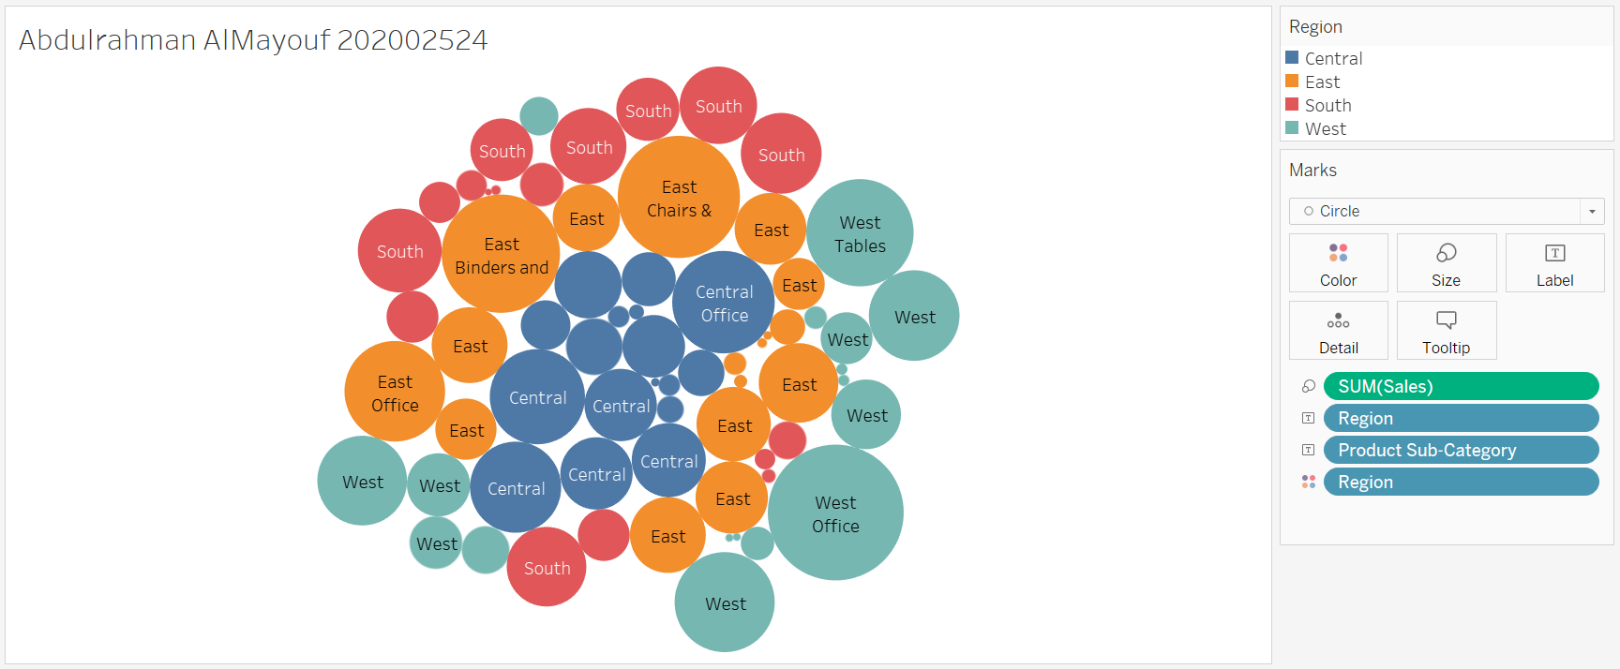

1. In tableau create a worksheet to display total profit per region per state. Apply colors and rabge formatting following the videos.

Copy paste the worksheet here

